Trip Agreement

Trip agreement is made between client and transporter by AARMS

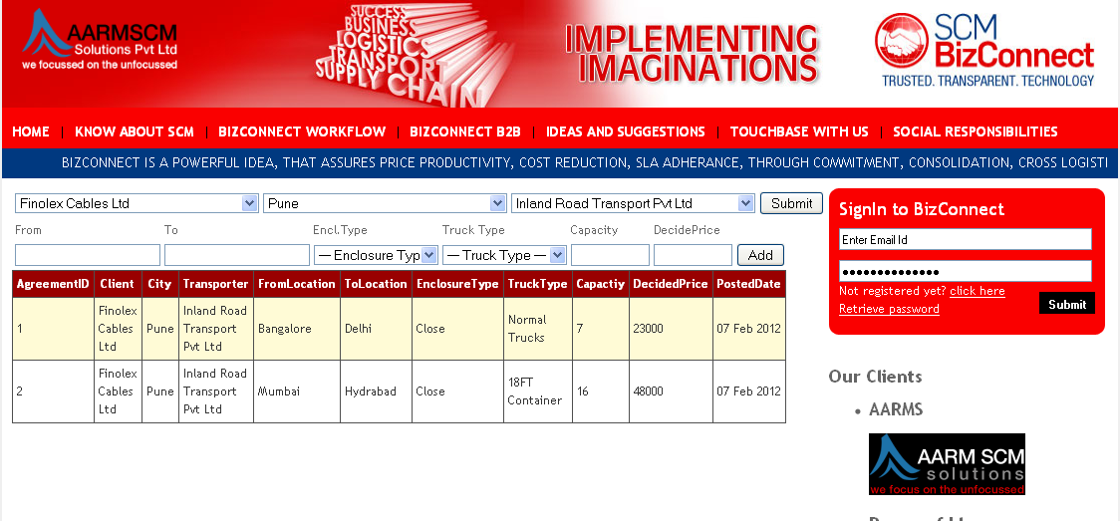

Trip Assignment

Trip Assignment is done by client,by select the trip date from the calender

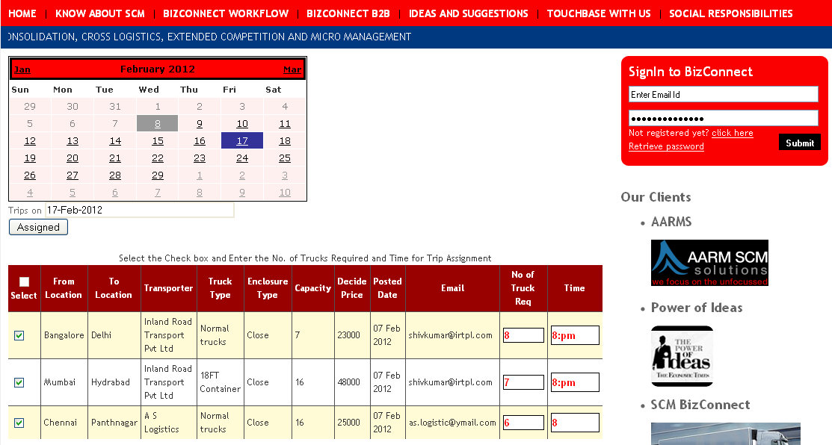

Trip Acceptance

Trip Acceptance is done by Transporter through email by clicking Click here to confirm

